CITY COUNCIL MEMORANDUM

From: | The Office of the City Manager | Date: | January 13, 2025
SUBJECT: | Discussion of possible revisions to Chapter 106 (Signs) of the North Richland Hills Code of Ordinances regarding electronic message boards and allowing wall signs on three faces of a building.
pRESENTER: | Clayton Comstock, Managing Director of Development Services

SUMMARY:
At the work session, staff will present background information on proposed amendments to the sign regulations to update standards for electronic message signs and allowing wall signs on three faces of the building.
Electronic message signs

Section 106-12(a) of the sign regulations provide standards for electronic message signs. The standards were originally adopted in May 1999 (Ordinance 2374), with the current standards adopted in November 2007 (Ordinance 2962).
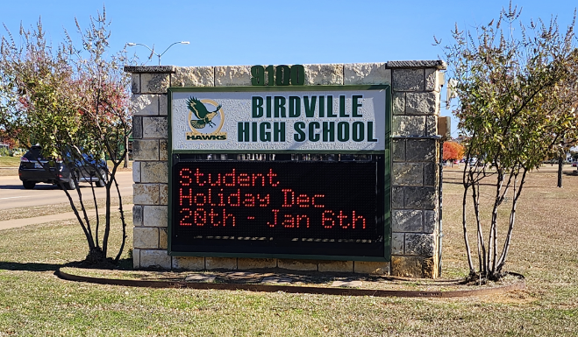
Example electronic message sign meeting current standards.

Under the current standards, there are two circumstances in which electronic message signs may be permitted:
- As part of a pole sign in the Freeway Corridor Overlay District along Loop 820 and SH 183; and

- In the U (School, Church, and Institutional) zoning district as part of a monument sign, and the display cannot exceed two-thirds of the sign message area. A standard monument sign structure is allowed to be 75 square feet in size, with a message area of 50 square feet. The electronic sign could not exceed 33 square feet. Most importantly, the electronic display is restricted to low intensity amber or red color lighting with a black background.
The standards have been in place for over 17 years. An update to the standards is proposed to address some of the common issues faced by staff and those institutions seeking approval of electronic message signs. These include:
- Current standards apply to a zoning district rather than a property or land use. This has become problematic when a public school or church—allowed in any zoning district—is located on property zoned something other than “U” Institutional.
- Current standards do not address residential adjacency or process for measuring illumination.
- Industry technology surpasses the limitations in the current standards.
- Monochrome (red and amber) signs are uncommon and difficult to source.
- The update would align standards with relevant digital billboard requirements found elsewhere in the Sign Code.
- Updated standards would allow for enhanced communication of community events.

One of the original intents of the standards was to permit electronic message signs for schools and houses of worship. However, since the current standards permit the signs based on zoning rather than land use, some Birdville ISD schools have requested zoning changes to the U (School, Church, and Institutional) district for the sole purpose of allowing the sign to be installed on the property. The proposed update would base the allowance for the signs on land use rather than zoning and could include land uses such as public and private schools, universities or colleges, houses of worship, outdoor amusement parks or outdoor theme parks, public parks, and governmental buildings.
The current standards lack relevant design and operational standards. The proposed update would include modest standards similar to those required for digital billboards, such as message transitions; automatic dimming technology; and prohibitions on animation, flashing, and moving images. Additionally, residential adjacency standards would be included for signs located within or next to single-family residential areas to protect residential property owners from light pollution and nighttime nuisances.

Wall signs

Section 106-13(b)(1) of the sign regulations limit wall signage to two facades on a commercial structure. Below are five examples within the past five years where wall signage was approved on three or four facades of a building. Staff will be seeking direction from City Council on whether to expand current standards to allow signage on three or four building facades.
BUSINESS | LOCATION | APPROVAL NOTES
Raising Canes | 5036 Rufe Snow Dr | Wall signs permitted on three (3) facades  (SRB 2021-01 – June 14, 2021)
Chick-fil-A | 6645 NE Loop 820 | Walls signs permitted on four (4) facades  (ZC22-0047 – May 8, 2023)
Starbucks | 6251 Davis Blvd | Walls signs permitted on four (4) facades  (ZC23-0048 – May 8, 2023)
Braum’s | 8364 Davis Blvd | Wall signs permitted on three (3) facades  (ZC 2019-17 – November 12, 2019)
Brakes Plus | 8612 Precinct Line Rd | Wall signs permitted on three (3) facades  (ZC 2019-21 – August 24, 2020)

At the work session, staff will present comparable standards from area benchmark cities and additional examples of prior approvals by the Sign Review Board and City Council.
If directed by City Council, staff will draft and send forward an ordinance formalizing any recommended revisions at the January 27, 2025, meeting.

