City Council MEMORANDUM

From: | The Office of the City Manager | Date: | September 22, 2025
SUBJECT: | Discuss and consider amending Ordinance No. 3924 to satisfy 2025 Tax Rate Adoption disclosure requirements.
pRESENTER: | Chase Fosse, Director of Budget & Research

Summary:
The City Council is requested to amend Ordinance No. 3924 which adopted the tax rate for Tax Year 2025 to satisfy state-mandated disclosure requirements.

General Description:
On September 8, 2025, the City Council held a public hearing on the proposed tax rate for Tax Year 2025 (Fiscal Year 2026) and subsequently approved Ordinance No. 3924 adopting the proposed tax rate. The adopted tax rate of $0.497841 per $100 of valuation was below both the No-New-Revenue tax rate ($0.498625) as well as the Voter-Approval tax rate ($0.511490).
The following statutory requirements for the adoption of the Tax Year 2025 tax rate were satisfied or exceeded:
- No public hearings were required since the proposed tax rate was below the No-New-Revenue rate. To promote transparency, two public hearings were conducted on August 25, 2025, and September 8, 2025.
- The required “Notice of Meeting to Vote on Tax Rate” was published in the City’s newspaper of record after the proposed tax rate was officially set by City Council on August 11, 2025. That notice included the following required table, which compared the proposed tax rate to the prior year’s adopted values: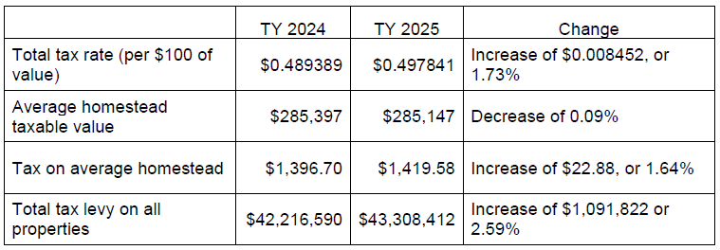
- Required notice requirements for the City’s website and Citicable were satisfied.
In addition to these requirements, state law requires specific language be included in the ordinance adopting the tax rate if the ordinance sets a tax rate that will impose an amount of taxes for maintenance and operations that exceed the taxes imposed for that purpose in the preceding year. This requirement was satisfied by including the following language in the adopting ordinance:
THIS TAX RATE WILL RAISE MORE TAXES FOR MAINTENANCE AND OPERATIONS THAN LAST YEAR’S TAX RATE.
Specific language required by a separate section of state law was omitted from the ordinance. Staff was notified of this discrepancy by the Tarrant County Assessor/Collector’s Office after submitting the adopted tax rate for billing purposes. Because the maintenance and operations portion of the tax rate exceeds the no-new-revenue maintenance and operations rate, the following language is required, and is proposed to be added to the amended ordinance:
THIS TAX RATE WILL EFFECTIVELY BE RAISED BY 2.058 PERCENT AND WILL RAISE TAXES FOR MAINTENANCE AND OPERATIONS ON A $100,000 HOME BY APPROXIMATELY $7.00.
Inclusion of this required language does not change the adopted tax rate, nor the fact that the City Council adopted a total tax rate of $0.497841 per $100 of valuation that was below both the total No-New-Revenue tax rate ($0.498625) as well as the Voter-Approval tax rate ($0.511490). This amendment simply incorporates notice language that was omitted from the original ordinance passed by City Council.

Recommendation:
Approve an amendment to Ordinance No. 3924 to satisfy 2025 Tax Rate Adoption disclosure requirements.

