Carport Permit Exception at 8900 Amundson Dr.

In accordance with Ordinance 3847/ article II/ 110-42:
This is the written request by Scott Hoberer for waiver or exception of Ordinance 3847/ article II/ 110-41(3) as it pertains to the addition of a carport to the AG zoned property at 8900 Amundson Dr. This property has had no zoning change since its annexation to the city of NRH and should not be subject to ordinance code requirements of section 118-293 created after the original zoning designations according to section 90-12. Furthermore, submission to the advised rezoning from AG to R-2 by the zoning and planning commission will revoke the future possibility to rezone back to AG property per Sec 118-294.

According to the Vision 2030 land use plan the intention of the city of NRH is to eliminate all AG zoned properties as shown in the land use plan map attached below. This is achieved through the ordinance that specifically targets AG zoned properties, such as Ordinance 3847/ article II/ 110-41(3), at the property owner’s expense of zoning fees, plat drawing and filing fees when a permit is applied for outside of minor remodel permits.

I have discussed with Clayton Comstock and Clayton Husband the possible options moving forward. Their recommendation is to continue with the rezoning and apply for a permit exception to approve a car port permit without a plat due to the high cost of acquiring a plat and I have already paid the rezoning fee. However, this path is concerning in the fact that once the rezoning is complete a permit without a plat could be denied and a plat deadline could be instated. Unless otherwise provided in writing by an authorized representative of North Richland Hills that the plat requirement will be waived until a future larger project permit is applied for so that the plat cost can be planned into that future project. I Scott Hoberer do not intend rezone this property from AG and/ or acquire a plat drawing at this time.

All referenced ordinances and vision 2030 land use plan map are listed below.

Reference Ordinances:

Ordinance 3847/ article II/ 110-42

(a) (b) (c) The Planning and Zoning Commission may approve modifications, waivers, or exceptions from these regulations upon written request from the applicant stating the grounds for such modification, waiver, or exception. Where the Planning and Zoning Commission finds that extraordinary hardships or practical difficulties may result from strict compliance with these regulations, or the purposes of these regulations may be served to a greater extent by an alternative proposal, it may approve modification s, waivers, or exceptions to these subdivision regulations. Such a finding will not have the effect of nullifying the intent and purpose of these regulations. The Planning and Zoning Commission may not approve modifications, waivers, or exceptions unless it makes findings based upon the evidence presented to it in each specific case that:
(1) The conditions upon which the request for a modification, waiver, or exception is based are unique to the property and are not applicable generally to other properties;
(2) A tract has peculiar physical surroundings, severe topographical conditions, or unique environmental qualities worthy of protection;
(3) Where a hardship to the owner would result rather than a mere inconvenience; or
(4) The modification, waiver, or exception will not have an adverse effect on the intent of these provisions or the comprehensive land use plan.

The applicant has the right to appeal the disapproval of a waiver or modification to the City Council.

sec 118/article V/ division 5/ sec 118-718/ D

(d)
Carport regulations. A carport shall comply with the following:
(1)
Property location criteria: A carport shall be located on the same tract or lot as the primary structure.
(2)
Applicable zoning districts: A carport shall be allowed in any zoning district.
(3)
Front building line: A carport shall not extend beyond the front building line.
(4)
Side building line: Side yard setback shall be the same as for the primary structure.

Ordinance 3847/ article II/ 110-41

Sec. 110-41. Building permits. (a) Plat required. A building permit for residential or commercial construction will not be issued for any primary building on any parcel of property unless a final plat has been approved and filed for record in the deed records of the county, except as follows:
(1) Where a primary residential structure exists, a building permit to repair or renovate the existing residential structure without adding new square footage may be issued on an unplatted lot, provided that the value of such proposed construction, including the cumulative value of any proposed and all previously permitted construction permits on the primary structure, does not exceed 50 percent of the current value of the existing structure, excluding the value of the land. Construction permits as used herein do not include electrical, plumbing, or similar non-construction activities.
(2) A building permit for electrical, plumbing, fence or similar non-construction activities may be issued on an unplatted lot in any zoning district except for building permits which include structural enclosures. (3) A building permit for an accessory structure may be issued on an unplatted lot on agriculturally zoned property provided regulations of Section 118-293 of the zoning ordinance have been met.

Sec. 90-12. - Code does not affect prior offenses, contracts, etc.

Nothing in this Code or the ordinance adopting this Code shall affect any offense or act committed or done or any penalty or forfeiture incurred or any contract or right established or accruing before the effective date of this Code.

Sec. 118-294. - General conditions.
The following general conditions shall be required of all development located within the AG district:
(1)
Fences. See article VIII of this chapter, screening and fencing regulations.
(2)
Parking. Off-street parking spaces shall be provided on every lot to accommodate four cars for each dwelling unit. At least two of such spaces shall be covered. No supporting member of any garage, carport, or other automobile structure shall be located within the required front building line. See article VII of this chapter, parking and loading regulations.
(3)
Accessory buildings. See article V of this chapter, supplementary district regulations for accessory building regulations. In addition, the location of stables and/or other accessory buildings associated with the keeping of livestock shall also be subject to the provisions of chapter 14 of this Code.
(4)
Customary home occupations. See article V of this chapter, supplementary district regulations.
(5)
Garage entry requirement. There is no garage entry requirement.
(6)
Masonry requirement. See article V of this chapter, supplementary district regulations.
(7)
Landscaping requirement. There is no landscaping requirement.
(8)
Changing AG zoning designation. Property, once changed from AG zoning to any other zoning district, shall not be changed back to AG zoning for any reason. Also property already zoned other than AG cannot be rezoned back to AG for any reason.
(9)
Subdivision of AG zoning districts. Property zoned AG cannot be subdivided and developed for any other purpose than strictly agriculture use without an approved zoning change.

Vision 2030 land use plan map:
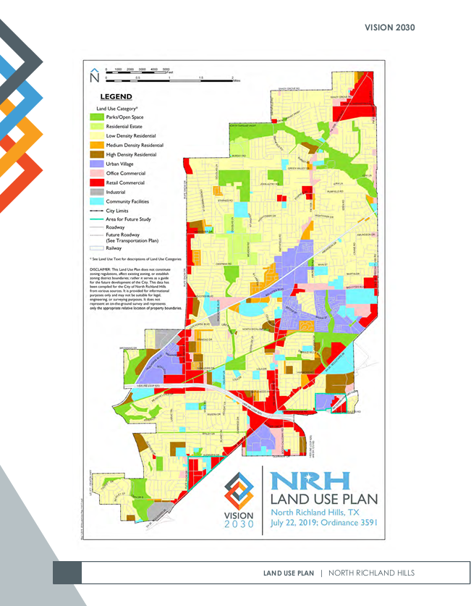

Reason for short notice written waiver and /or exception request, requestor, and date of request:

This written request submitted by the property owner Scott Hoberer on 11/10/2024 in response to the short notice of city council meeting on 11/11/2024 notification from Clayton Husband on 11/08/2024 via email.

