Planning and Zoning Commission MEMORANDUM

From: | Planning & Zoning Department | Date: | January 16, 2025
SUBJECT: | ZC24-0116 Public hearing and consideration of a request from CJ Real Estate LLC for a revision to Planned Development 114 to allow a quick service restaurant at 7601 Boulevard 26, being 0.66 acres described as a portion of Lot 3, Block 1, Richland Terrace Addition.
pRESENTER: | Clayton Comstock, Managing Director of Development Services

Summary:
On behalf of 7601 Boulevard 26 LLC (property owner), CJ Real Estate LLC is requesting a revision to Planned Development 114 to allow a quick service restaurant on a 0.66-acre property located at 7601 Boulevard 26.
General Description:
The 28,820-square foot site under consideration is located on the west side of Boulevard 26 between City Point Drive and Rodger Line Drive. The site is located in the front parking area of the WareSpace property. The applicant proposes to develop a site for a Starbuck’s quick service restaurant with drive-through service.
A site plan package for the property is attached. Planned improvements to the site include construction of a new 2,200-square-foot building with drive-through service and associated site improvements. The zoning ordinance requires special use permit approval for a quick service restaurant. In addition, the ordinance includes specific standards for the design and layout of drive-through lanes, and the design complies with those standards.
Landscaped areas on the property cover 18% of the site. These areas include a 15-foot-wide landscape setback adjacent to Boulevard 26, landscaped areas adjacent to the drive-through lane, parking lot landscaping, and buffer areas between the site and adjacent WareSpace building.
The parking lot contains 29 parking spaces and vehicle stacking area for 12 cars in the drive-through lane. The WareSpace site has direct driveway access to Boulevard 26, and the Starbuck’s site would share access to the driveway. The driveway would be widened from 24 feet to 30 feet, which is typical of most commercial driveways. Additionally, a drive aisle is planned to connect to the adjacent convenience store site. The dedication of common access easements on the property would be necessary when the property is replatted.
Elevations of the building are attached. The building would be constructed primarily of brick and synthetic wood materials, with metal canopies and accents. The elevations also indicate wall signage on three elevations of the building. While the sign ordinance permits wall signage on only two faces of a building, the applicant has requested approval to place wall signs on three sides of the building.
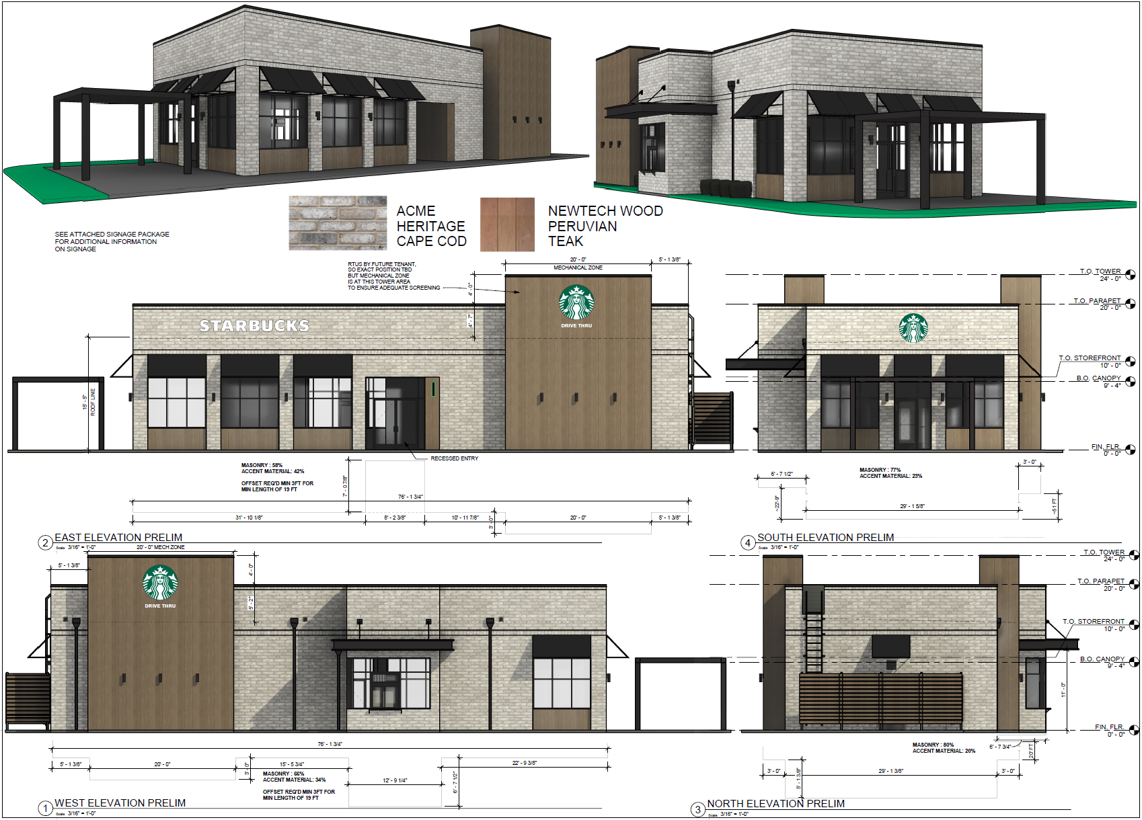
The proposed conditions of approval for this NR-PD district are attached. Applications for rezoning to this district provide an opportunity to address modifications to specific site development and building design standards for the site. These conditions are based on the applicant’s proposed development of the property. These conditions may be modified throughout the public hearing process, but they are subject to final approval by City Council.
The property is zoned NR-PD (Nonresidential Planned Development). The land use and development regulations applicable to the NR-PD allow for additional buildings to be constructed on the property but limit the land uses in those buildings to those permitted in the C-1 (Commercial) district. Land use that requires a special use permit in that district, such as a quick service restaurant, are only allowed if a special use permit is approved for the use. This provision is the basis for the application being processed as a special use permit rather than as an amendment to the NR-PD district.
LAND USE PLAN: This area is designated on the Land Use Plan as Retail Commercial. The Retail Commercial land use category provides sites for community and regional shopping centers, commercial establishments, and employment centers. These sites are typically located on highways and major thoroughfares at key intersections.
CURRENT ZONING: The property is currently zoned NR-PD (Nonresidential Planned Development). The zoning was approved by City Council on December 13, 2021 (Ordinance 3721). The NR-PD provides for a base zoning district of C-2 (Commercial) and is intended to allow for a mix of small businesses to utilize for e-commerce, business logistics, crafting and assembling products for sale online, light manufacturing, product repair and servicing, wholesale distribution, and ancillary warehousing associated with the primary uses.
SURROUNDING ZONING | LAND USE:
DIRECTION | ZONING | LAND USE PLAN | EXISTING LAND USE
NORTH | C-2 (Commercial) | Retail Commercial | Convenience store with fuel sales and North Hills Village shopping center
WEST | C-2 (Commercial) | Retail Commercial | WareSpace and retail uses
SOUTH | C-1 (Commercial) | Urban Village | Quick service restaurant uses
EAST | C-2 (Commercial) | Retail Commercial | Retail and service uses

PLAT STATUS: The property is platted as Lot 3, Block 1, Richland Terrace Addition. The property will likely be replated to subdivide the Starbuck’s use from the WareSpace use for property conveyance purposes. That would likely be a minor replat reviewed and approved at the Development Review Committee (staff) level only.
CITY COUNCIL: The City Council will consider this request at the January 27, 2025, meeting following a recommendation by the Planning and Zoning Commission.
Recommendation:
Approve ZC24-0116.

